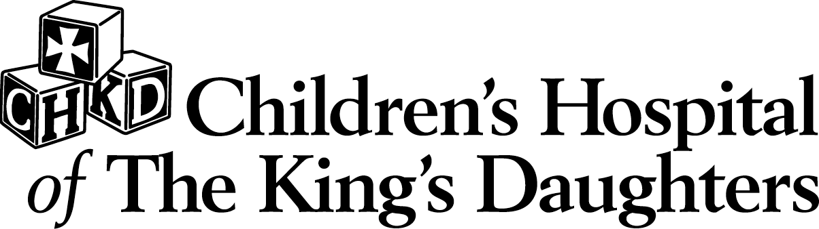
Diabetes Center
Insulin Pump
Upgrade Class

This session is designed for patients who wish
to upgrade their pump and features.
Exhibits by Animas Corporation,
Medtronic MiniMed, OmniPod, and Smiths Medical.

1st Thursday of the Month
(class not offered August & January)
6:00 to 7:30 p.m.

CHKD Diabetes Center, 2nd Floor
601 Children’s Lane, Norfolk

Register by calling (757) 668-8609
Bring all glucose meters for downloading

Mark the Date

